All rights reserved the document is author by <https://github.com/harshchokshi/>

The document is provided only for understanding the details of pom.xml to answer questions like:

* Why list of dependencies is added?
* Why Maven Surefire Plugin is added?
* Why UTF source encoding is provided?
* What types of errors I am going to face if I miss out any of the dependencies?

# List of Dependencies Pom.xml

|  |  |
| --- | --- |
| TestNG | To use TestNG framework for test automation. |
| Selenium | To automate web application testing. |
| Web Driver Manager | To manage web driver instead of using system property |
| Relevant Codes | To generate Extent Report |
| SLF4J | To remove SLF4G logger warning |
| Commons IO | To take screenshot |

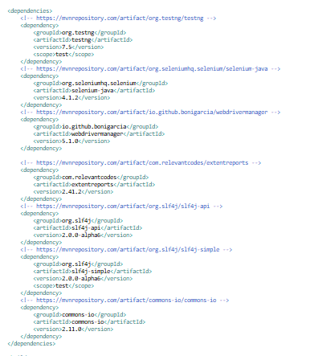

<dependencies>

<!-- https://mvnrepository.com/artifact/org.testng/testng -->

<dependency>

<groupId>org.testng</groupId>

<artifactId>testng</artifactId>

<version>7.5</version>

<scope>test</scope>

</dependency>

<!-- https://mvnrepository.com/artifact/org.seleniumhq.selenium/selenium-java -->

<dependency>

<groupId>org.seleniumhq.selenium</groupId>

<artifactId>selenium-java</artifactId>

<version>4.1.2</version>

</dependency>

<!-- https://mvnrepository.com/artifact/io.github.bonigarcia/webdrivermanager -->

<dependency>

<groupId>io.github.bonigarcia</groupId>

<artifactId>webdrivermanager</artifactId>

<version>5.1.0</version>

</dependency>

<!-- https://mvnrepository.com/artifact/com.relevantcodes/extentreports -->

<dependency>

<groupId>com.relevantcodes</groupId>

<artifactId>extentreports</artifactId>

<version>2.41.2</version>

</dependency>

<!-- https://mvnrepository.com/artifact/org.slf4j/slf4j-api -->

<dependency>

<groupId>org.slf4j</groupId>

<artifactId>slf4j-api</artifactId>

<version>2.0.0-alpha6</version>

</dependency>

<!-- https://mvnrepository.com/artifact/org.slf4j/slf4j-simple -->

<dependency>

<groupId>org.slf4j</groupId>

<artifactId>slf4j-simple</artifactId>

<version>2.0.0-alpha6</version>

<scope>test</scope>

</dependency>

<!-- https://mvnrepository.com/artifact/commons-io/commons-io -->

<dependency>

<groupId>commons-io</groupId>

<artifactId>commons-io</artifactId>

<version>2.11.0</version>

</dependency>

</dependencies>

# Maven Surefire plugin is used to generate HTML report

For more details [visit](https://www.lambdatest.com/blog/selenium-maven-jenkins-integration/).

<build>

<plugins>

<plugin>

<groupId>org.apache.maven.plugins</groupId>

<artifactId>maven-surefire-plugin</artifactId>

<version>3.0.0-M5</version>

<configuration>

<suiteXmlFiles>

<suiteXmlFile>testng.xml</suiteXmlFile>

</suiteXmlFiles>

</configuration>

</plugin>

<plugin>

<groupId>org.apache.maven.plugins</groupId>

<artifactId>maven-surefire-report-plugin</artifactId>

<version>3.0.0-M5</version>

</plugin>

</plugins>

</build>

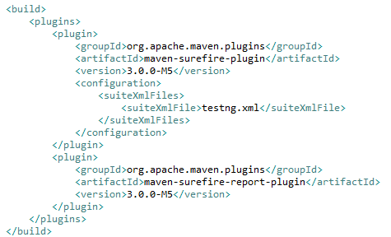

# To remove UTF encoding error in the Jenkins console output of job run

Maven complier source encoding properties is set

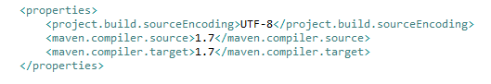

<properties>

<project.build.sourceEncoding>UTF-8</project.build.sourceEncoding>

<maven.compiler.source>1.7</maven.compiler.source>

<maven.compiler.target>1.7</maven.compiler.target>

</properties>

# Complete pom.xml

<?xml version=*"1.0"* encoding=*"UTF-8"*?>

<project xmlns=*"http://maven.apache.org/POM/4.0.0"*

xmlns:xsi=*"http://www.w3.org/2001/XMLSchema-instance"*

xsi:schemaLocation=*"http://maven.apache.org/POM/4.0.0 http://maven.apache.org/xsd/maven-4.0.0.xsd"*>

<modelVersion>4.0.0</modelVersion>

<groupId>SampleProj</groupId>

<artifactId>SampleApp</artifactId>

<version>0.0.1-SNAPSHOT</version>

<name>SampleApp</name>

<!-- FIXME change it to the project's website -->

<url>http://www.example.com</url>

<properties>

<project.build.sourceEncoding>UTF-8</project.build.sourceEncoding>

<maven.compiler.source>1.7</maven.compiler.source>

<maven.compiler.target>1.7</maven.compiler.target>

</properties>

<dependencies>

<!-- https://mvnrepository.com/artifact/org.testng/testng -->

<dependency>

<groupId>org.testng</groupId>

<artifactId>testng</artifactId>

<version>7.5</version>

<scope>test</scope>

</dependency>

<!-- https://mvnrepository.com/artifact/org.seleniumhq.selenium/selenium-java -->

<dependency>

<groupId>org.seleniumhq.selenium</groupId>

<artifactId>selenium-java</artifactId>

<version>4.1.2</version>

</dependency>

<!-- https://mvnrepository.com/artifact/io.github.bonigarcia/webdrivermanager -->

<dependency>

<groupId>io.github.bonigarcia</groupId>

<artifactId>webdrivermanager</artifactId>

<version>5.1.0</version>

</dependency>

<!-- https://mvnrepository.com/artifact/com.relevantcodes/extentreports -->

<dependency>

<groupId>com.relevantcodes</groupId>

<artifactId>extentreports</artifactId>

<version>2.41.2</version>

</dependency>

<!-- https://mvnrepository.com/artifact/org.slf4j/slf4j-api -->

<dependency>

<groupId>org.slf4j</groupId>

<artifactId>slf4j-api</artifactId>

<version>2.0.0-alpha6</version>

</dependency>

<!-- https://mvnrepository.com/artifact/org.slf4j/slf4j-simple -->

<dependency>

<groupId>org.slf4j</groupId>

<artifactId>slf4j-simple</artifactId>

<version>2.0.0-alpha6</version>

<scope>test</scope>

</dependency>

<!-- https://mvnrepository.com/artifact/commons-io/commons-io -->

<dependency>

<groupId>commons-io</groupId>

<artifactId>commons-io</artifactId>

<version>2.11.0</version>

</dependency>

</dependencies>

<build>

<plugins>

<plugin>

<groupId>org.apache.maven.plugins</groupId>

<artifactId>maven-surefire-plugin</artifactId>

<version>3.0.0-M5</version>

<configuration>

<suiteXmlFiles>

<suiteXmlFile>testng.xml</suiteXmlFile>

</suiteXmlFiles>

</configuration>

</plugin>

<plugin>

<groupId>org.apache.maven.plugins</groupId>

<artifactId>maven-surefire-report-plugin</artifactId>

<version>3.0.0-M5</version>

</plugin>

</plugins>

</build>

</project>